Engineer Intern Position in CNC Machine Factory in New Jersey, USA
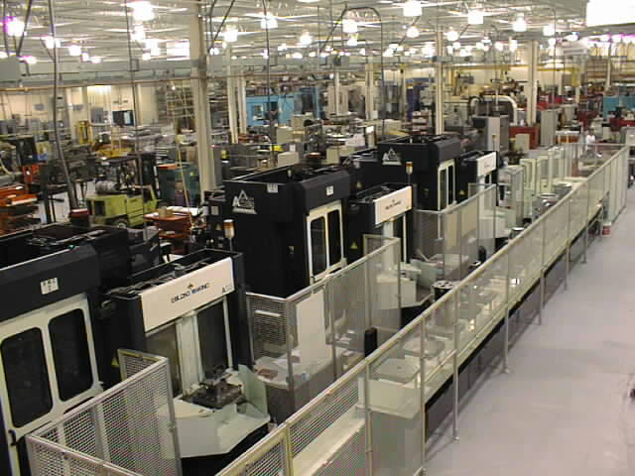

DESCRIPTION

This is an engineering intern position at a close tolerance precision CNC Factory in New Jersey for the summer, with a possibility of full-time job offer next year i. We offer hands-on practical, technical and machine operator training.
DUTIES
o Perform routine aspects of mechanical engineering requiring knowledge and application of basic engineering principles under close supervision.
o Use computer-assisted engineering software and equipment to perform engineering tasks.
o Operate CNC machines on a regular basis
o Assist in CNC programming, machine operation and setup on the shop floor
o Provide support to engineering staff members as needed.

QUALIFICATIONS
Education and/or Experience
Enrolled with at least a Junior status in a Bachelors Degree Mechanical Engineering, Mechatronic Engineering or IT Engineering program at an accredited University with a Minimum GPA of 3.0
Language Skills
English High level.

Other Skills/Abilities
AutoCAD experience required, ProE experience preferred, FEA experience preferred, CNC Programming preferred
DURATION & ACCOMODATION
From 2012 July till 2013 June
We offer accommodation at a nearby location to our facility. Flight and visa expenses are not covered.
Stipend will be provided to cover living expenses at $10.00/hour.

APPLICATION PROCEDURE & CONTACT DETAILS

If you are interested please send your CV and motivation letter in English language to the following addresses until the 15th of March, 2012.

Ladányi Benjámin
bladanyi@arlingtonmachine.com

The selected applicants will be informed after the deadline.

www.arlingtonmachine.com
www.titanti.com

