Engineer Intern Position in CNC Machine Factory in New Jersey, USA
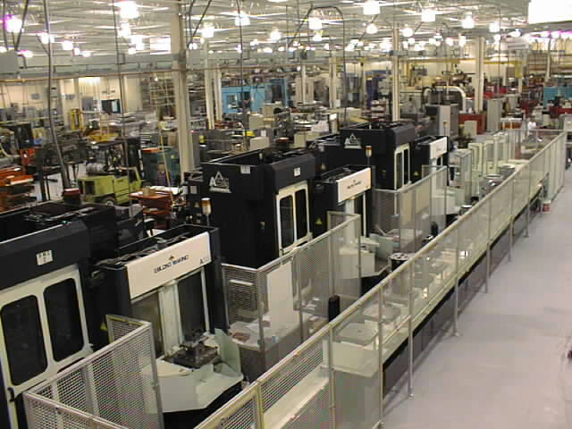

DESCRIPTION

This is an engineering intern position at a close tolerance precision CNC Factory in New Jersey for the summer, with a possibility of full-time job offer next year in Miskolc at our brand new facility. We offer hands-on practical, technical and machine operator training.
DUTIES
o Perform routine aspects of mechanical engineering requiring knowledge and application of basic engineering principles under close supervision.
o Use computer-assisted engineering software and equipment to perform engineering tasks.
o Operate CNC machines on a regular basis
o Assist in CNC programming, machine operation and setup on the shop floor
o Provide support to engineering staff members as needed.
QUALIFICATIONS
Education and/or Experience
Enrolled with at least a Junior status in a Bachelors Degree Mechanical Engineering, Mechatronic Engineering or IT Engineering program at an accredited University with a Minimum GPA of 3.0
Language Skills
English High level.

Other Skills/Abilities
AutoCAD experience required, ProE experience preferred, FEA experience preferred, CNC Programming preferred
DURATION & ACCOMODATION

From July till September
We offer accommodation at a nearby location to our facility. Flight and visa expenses are not covered.
Stipend will be provided to cover living expenses at $7.50/hour.

APPLICATION PROCEDURE & CONTACT DETAILS

If you are interested please send your CV and motivation letter in English language to the following addresses until the 15th of June 2011.

Szentkatolnay Kristóf
project manager

szentkatolnay.kristof@innotet.hu

Ladányi Benjámin
financial analyst

benjamin.ladanyi@arlingtonmachine.com

The selected applicants will be informed after the deadline.

www.arlingtonmachine.com
www.titanti.com

