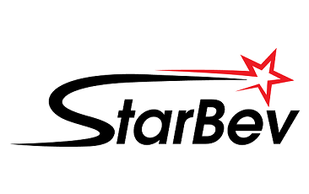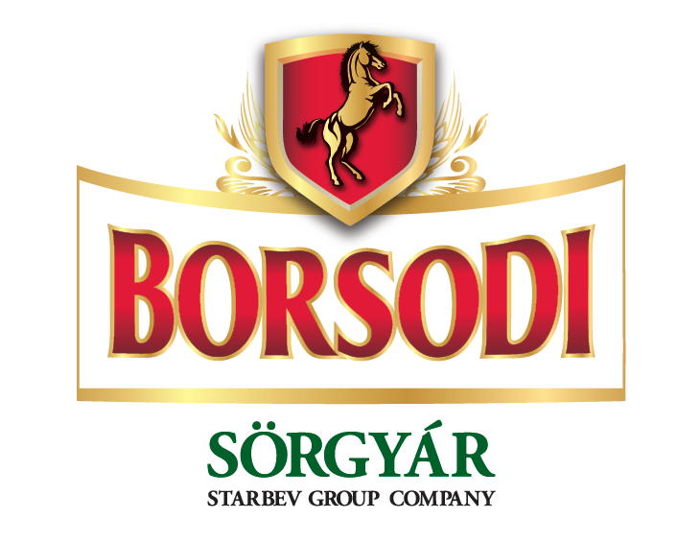

Welcome in Borsodi Sörgyár, a StarBev Group company, owner of the Hungarian market No1. local flagship brand Borsodi and local distributor of StarBev owned Staropramen and AB-InBev owned Beck’s, Stella, Hoegaarden, Leffe, Löwenbrau and Belle-Vue, with 1.46 mio hectoliters total sales volume and 24% market share in 2010, with a central office in Budapest and a brewing plant located in Bőcs, Hungary.

Trainee program for University Graduates

Borsodi Sörgyár presents 1-Year Trainee program which focuses on the field of Supply.
Successful candidate will have opportunity to learn and experience Beer Business from inside in one of the leading Brewery in Hungary which is a part of European leading brewing Group StarBev. Detailed induction phase will be combined with on the job trainings and other learning methods and tools which will help our Trainee to progress his/her career.

Basic prerequisites for our candidates:

- Finished Master Degree this or last Year
- Worked during studies
- Ready to start from the basic positions
- Clear vision about their future Career stream

Ideal candidate’s profile:

- Master Degree (preferably) in Mechanical Engineering
- Open minded, friendly and communicative person
- Good level of English (Advanced level)
- Has advanced PC skills (Word, Excel, Power point)
- Has healthy ambitious and SMART expectation
- Eager to learn and fast learner
- Able to cope with criticism and disappointment
- Able to self motivate and look for information on his/her own
- Has realistic expectation in regard to work on starting position
- Does not mind to work in open space offices/plant area
- Respects cosmopolitan environment
- Has drive and willingness to work for brewery business and FMCG in general
- Team player and has winning attitude

We offer:

- Competitive salary and benefits
- Interesting business area with tradition
- Opportunity to participate in the development of your favorite brands
- Chance to work for an innovative company
- Job opportunity in stable business sector
- Background of the major independent FMCG Company in this region
- Informal and welcoming environment
- Young, dynamic and enthusiastic team

Location: Bőcs, Borsod-Abaúj-Zemplén county

Contact:

If you are interested in our Trainee program, please send your CV and motivation letter to: trainee.program@starbev.com between 4th – 15th April 2011.
Please mention “Borsodi Trainee Program - Supply” as the subject of your email.

Please note the sending your application (CV and motivation) will give your explicit consent to process and store your personal data provided by you via attached CV. This data are providing for definite period - 1 year. The Collector Borsodi Sörgyár Kft. with its registered office at Hungary, 3574 Bőcs, Rákóczi u. 81. is entitle for processing of your personal data for purposes of recruitment and job selection purposes within Starbev Group. Providing personal information is voluntary, the personal data may be processed by the processor (ACCESS ASSESSMENT s.r.o., a member of SHL Partner Network), which entrusts the collector; otherwise they will not be disclosed to third parties.
This consent can be withdrawn at any time. You further acknowledge that you have a right of access to your personal data and if you believe that the controller performs processing of your personal data in violation of the protection of your private life or in violation of the law, especially if personal data is inaccurate with regard to processing purposes, you can ask for clarification or ask the collector to correct or eliminate such a situation. In particular, it may be blocking, correcting, adding or deleting the personal data. If the collector does not comply with this request, you have the right to contact the Office for Personal Data Protection or other competent organ of state government.

