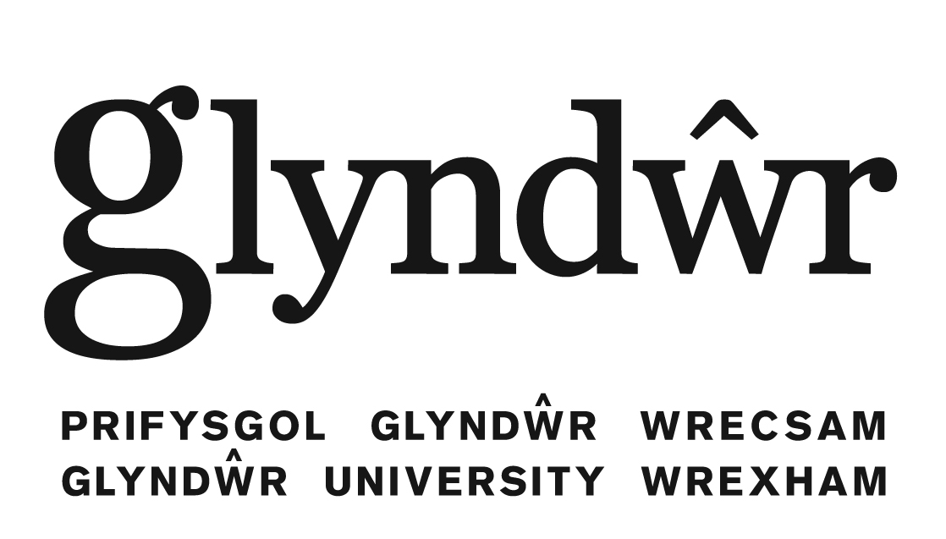

Second Language Learning Centre
ENGLISH LANGUAGE SUMMER SCHOOL 2012

Course Overview This four week intensive English language and cultural studies programme offers 21 hours a week guided learning opportunities at intermediate, upper intermediate and advanced levels of English – subject to sufficient student numbers.
The Summer School is for students of any first language other than English who are looking for a short but intensive experience of studying in Wales. Participants will be introduced to British Culture and public society through a tailored course of academic tuition, educational trips to the nearby cities of Liverpool and Chester, and excursions to the most picturesque and historic sites of northern Wales and western England.
Tuition and credits On successful completion students will be awarded a Glyndŵr University Certificate of Continuing Education and 20 Higher Education credits (=10 ECTS) which can be used towards a Higher Education degree as appropriate.
Social programme Social events and weekend trips are included in the price and will take place according to the schedule.
Accommodation Students are provided with on-campus accommodation or are allocated to University housing a short distance from the University. Alternatively, help will be provided with other accommodation arrangements as appropriate.
Liaison Scheduled transfers from/to Manchester airport are included in the programme fees as appropriate. International Officers and the Second Language Learning Centre will support you during your stay in Wrexham. You will also be advised on free time activities as well as on individual plans and visits.

Minimum Age: 18 years

Fees: £1400 including tuition, tuition material, 3 trips, 1 guided tour, 2/3 social events, accommodation, and airport transfers subject to schedule and prior agreement of times.

Start dates 2 July 2012 and 30 July 2012 (different start dates can be arranged for groups of a minimum of 15 participants)

Duration 4 weeks (different durations can be arranged for groups of a minimum of 15 participants – please ask for a quote)

Terms and conditions:
Upon receipt of an application form an initial confirmation letter will be issued to the applicant normally within four working days. This will be sent as an email attachment, or in an airmail letter if preferred by the applicant.
A letter of acceptance for the course can only be issued upon receipt of a deposit of £700.
The balance is payable at least 10 days before the commencement of the course.
Deposits will only be refunded under exceptional circumstances, e.g. an unsuccessful visa application or a medical condition. Documentary proof is required, and a non-refundable administration fee of £100 applies.

More details can be found at http://saturn.glyndwr.ac.uk/englishsummer/
Deadline for applications one month prior to start of course
Contact Dr. Leila Luukko-Vinchenzo tel. +44 1978 293553
(Second Language Learning Centre)
or email languages.summer@glyndwr.ac.uk

