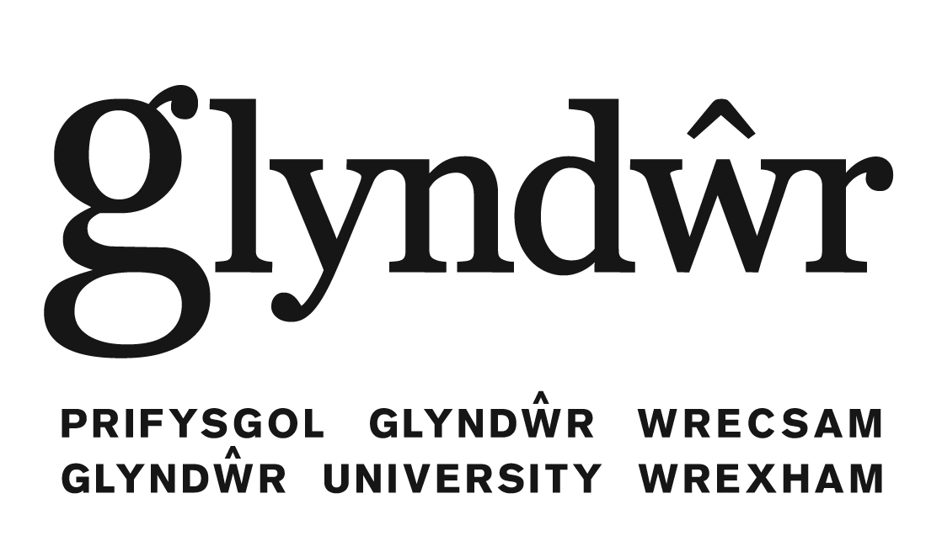

Second Language Learning Centre:
- A newly established and rapidly expanding Language Centre,
- With highly experienced, qualified and enthusiastic staff
- International environment in Wales close to the English cities of Chester, Liverpool, Manchester and only 3 hrs from London; easy access to native speakers of many languages

PROGRAMMES OFFERED:
In-sessional English programmes:
- 1) English for Specific Academic Purposes; separate programmes for undergraduate and postgraduate students, no extra fee, SUBJECT SPECIFIC AND ACADEMIC, continuous assessment in all skills
- 2) Evening classes in ESOL/EFL (English for Professional Purposes): end of semester tests in Reading, Listening, Writing, Speaking; 20 UK HE credits + transcript; 2011/12 fee: £150.00; levels offered: Intermediate (IELTS 4.5), Upper Intermediate (IELTS 5.5), Advanced (IELTS 6.5)
  - 3) Foreign Languages: 1. Electives: (no extra fee) Chinese, German, Spanish, Upper Intermediate English for Professional Purposes; Extra FLs: French, Italian, Japanese, Russian etc.; Semester 2 only: enrolment in December, 2011/2012 fee: £225
  - http://www.glyndwr.ac.uk/en/Undergraduatecourses/Languageclassesandsupport/Englishlanguagesupport/

Short courses in ESOL (general), or Continuing Professional Development in English (CPD)
- 1) Tailor-made programmes of varying lengths; fees on request
- 2) CPD: intensive English language programmes for professional groups at different levels and of different lengths, e.g. Continuing Professional Development for teachers of English, for business executives, for pilots, journalists etc.; combination of English/culture/subject specific notions; fees on request
Summer School: 4 weeks intensive English language and cultural studies at 3 levels + social programme; start dates in July and August;
information and enrolments: http://saturn.glyndwr.ac.uk/englishsummer/

Pre-sessional English/Academic English: length of course dependent on previous knowledge of English and the target programme; improved English language abilities, for everyday communication as well as for academic purposes

International Foundation Diploma:
- improved English language abilities, for everyday communication as well as for academic purposes; study skills for an academic career; experience of student life before starting main course; access to all University facilities
- September – May (applicants with 4.5 IELTS) or February – May (applicants with 5.0 IELTS); target: IELTS 6.0 equivalence for undergraduate entry; can be followed up by pre-sessional English for postgraduate entry (IELTS 6.5 equivalent) during August-September
- modules: English Language 1 and 2, British Culture, Study Skills and British Culture, Integrated Studies: Introduction to Undergraduate Studies

MA Advanced ESOL (English for Speakers of Other Languages)
- raises English language skills in all four areas; enhances cultural, socio-political and economic awareness; intercultural communication skills; linguistic analysis and research skills; exposure to an international environment at Glyndwr University; professional advice and support for CPD, e.g. CELTA/MA in translation and/or interpreting
- entry requirements: First degree in English language/literature/linguistics/ESOL/TESOL/EFL; 2:2 or above; IELTS 6.5
- modules: Applied Linguistics 1 and 2, Advanced EFL, Research and Study Skills for Languages and Area Studies; Contemporary Britain; Intercultural Communication; Dissertation
- career prospects: translating; interpreting; teaching; research; marketing; politics; journalism; management/administration
- http://www.glyndwr.ac.uk/en/Postgraduatecourses/MAAdvancedESOL/

Contacts and further information:
Dr. Leila Luukko-Vinchenzo; Head of the Second Language Learning Centre:
l.luukkovinchenzo@glyndwr.ac.uk
http://www.glyndwr.ac.uk/en/Ourcampusesandfacilities/SecondLanguageLearningCentre/
languages.foreign@glyndwr.ac.uk

