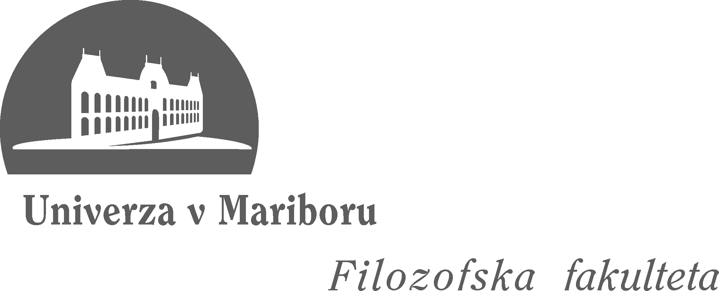

UNIVERSITY OF MARIBOR, FACULTY OF ARTS
Koroska cesta 160, 2000 Maribor, Slovenia
http://www.ff.uni-mb.si/

7th Maribor International Summer School
“AT THE HUB OF CULTURE: THE EUROPEAN CULTURAL CAPITAL 2012”
University of Maribor, Faculty of Arts
25th June - 5th July 2012

APPLICATION FORM

PERSONAL DETAILS
Last name
First name(s)
Date of Birth
Nationality
Permanent Address
Telephone
E-mail
INFORMATION ON STUDIES
Name and address of University
Name and address of Faculty and Department
Study programme
Year of Studies

PLEASE MARK WITH AN “x”
I need an official Letter of Invitation.
I need a Letter of Guarantee for Visa.

Please send your application to tjasa.mohar@um.si by 31st May 2012.
The applicants will be notified of acceptance by 7th June 2012.

The students will be charged a registration fee in the amount of 30 EUR (to be paid upon arrival).
The fee covers accommodation, lectures and workshops, language courses, excursion and field trip as well as sports activities.

